**Grupo 10: Isabella Neves, Lucas Barroso, Mariana Namie, Paula Maria, Sofia Valadares, Vitor Daniel**

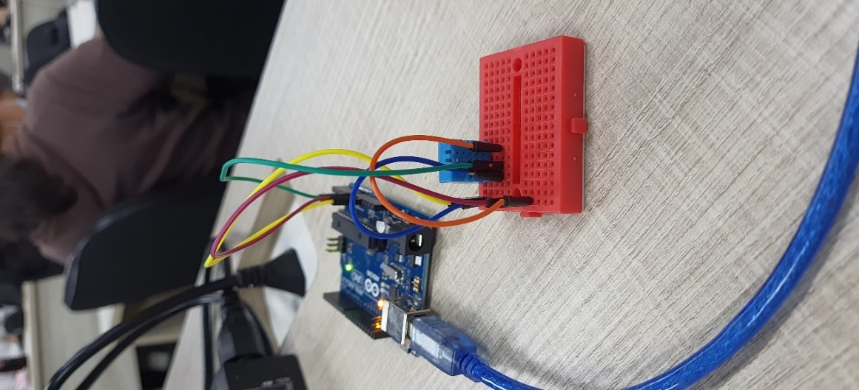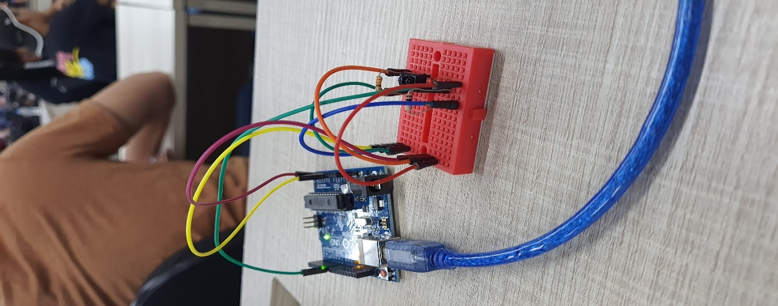

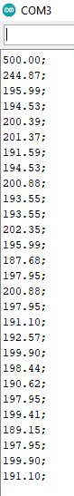

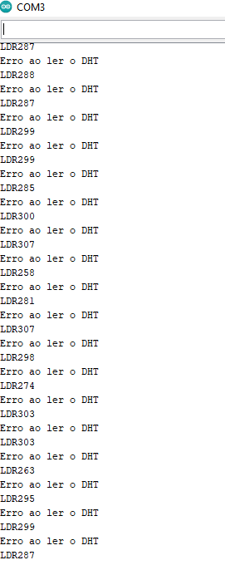

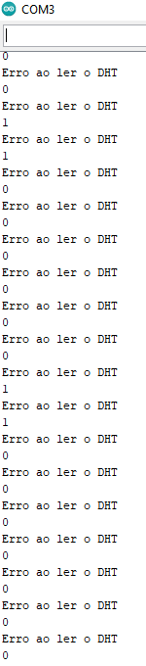

TEMPERATURA

dados: max 32,26 min 24,4

projeto: max 30 min 20

30 = 32,26 * a + b

20 = 24,4 * a +b

10 = 7,86*a

a = 1,27

20 = 24,4 * 1,27 + b

20 = 30,98 + b

b = -10,98

UMIDADE

dados: max 72,06% min 69%

projeto: max 12% min 7%

12 = 72,06 + b

7 = 69 *a +b

5 = 3,06*a

a = 5/3,06

12= 72*(5/3,06) + b

12 = 117,64 + b

b= 12 - 117,64

b = - 105,64

1 – Fotos dos 4 sensores montados

2- Imprimir massa de dados de 100 capturas referentes ao sensor de uso do grupo

3 – Ajuste matemático para que a saída do sensor seja a desejada

4 – Quartis de dados distintos

5 – Ajuste da API para plotar esses dados na tela

6- Criação de faixas de alerta a partir da 1º base de dados calculada

7- Plotar no Excel 5 gráficos com as faixas de controle estipuladas em 6, e utilizar as massas de dados criadas em 3,4

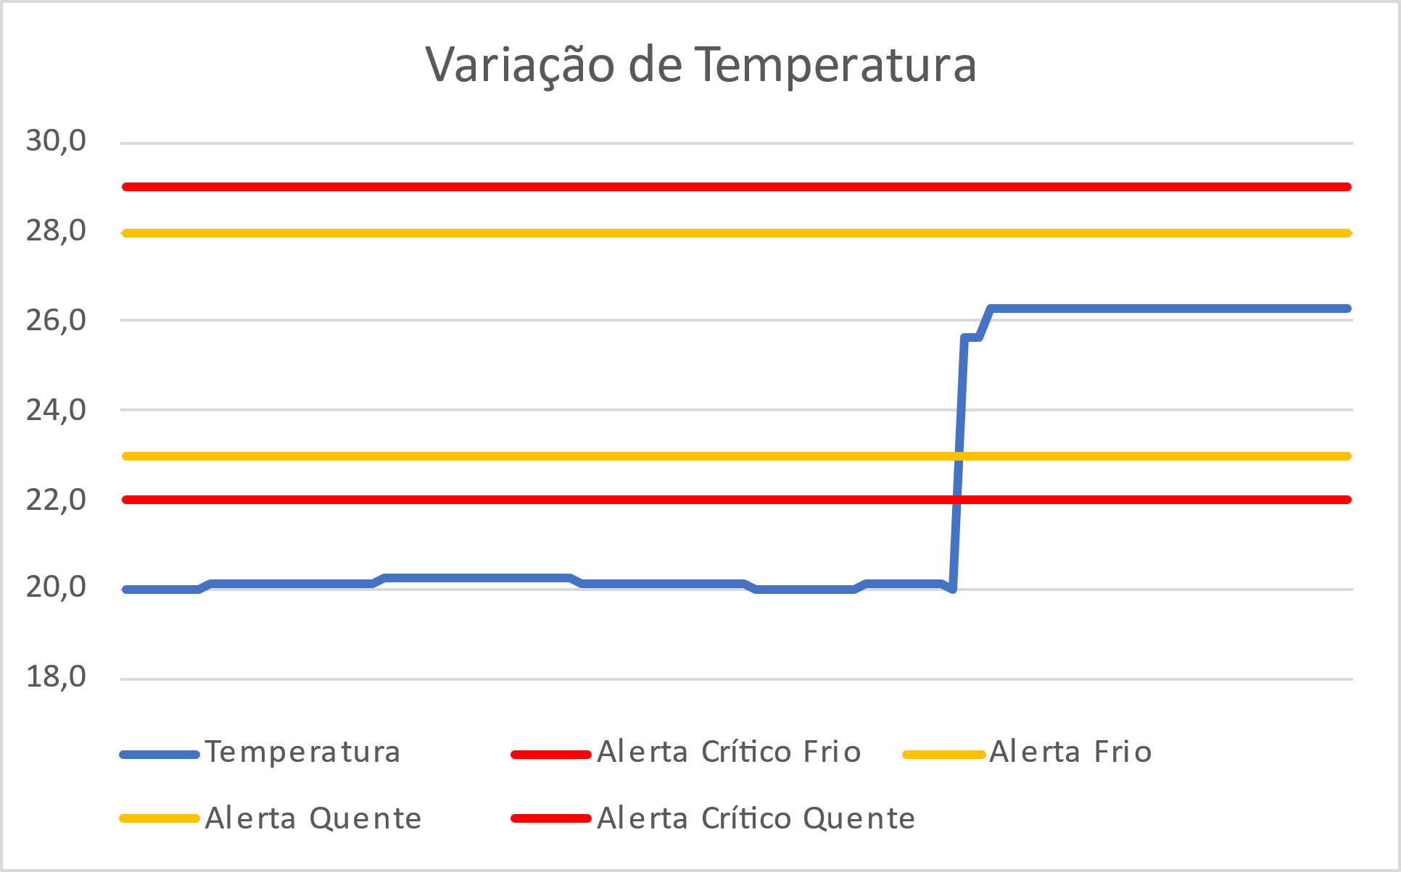

|  |  |  |  |  |  |
| --- | --- | --- | --- | --- | --- |
|  | Temp.Real | Alerta Crítico Frio | Alerta Frio | Alerta Quente | Alerta Crítico Quente |
| 20,0 | 24,4°C | 22,°C | 23,°C | 28,°C | 29,°C |
| 20,0 | 24,4°C | 22,°C | 23,°C | 28,°C | 29,°C |
| 20,0 | 24,4°C | 22,°C | 23,°C | 28,°C | 29,°C |
| 20,0 | 24,4°C | 22,°C | 23,°C | 28,°C | 29,°C |
| 20,0 | 24,4°C | 22,°C | 23,°C | 28,°C | 29,°C |
| 20,0 | 24,4°C | 22,°C | 23,°C | 28,°C | 29,°C |
| 20,0 | 24,4°C | 22,°C | 23,°C | 28,°C | 29,°C |
| 20,1 | 24,5°C | 22,°C | 23,°C | 28,°C | 29,°C |
| 20,1 | 24,5°C | 22,°C | 23,°C | 28,°C | 29,°C |
| 20,1 | 24,5°C | 22,°C | 23,°C | 28,°C | 29,°C |
| 20,1 | 24,5°C | 22,°C | 23,°C | 28,°C | 29,°C |
| 20,1 | 24,5°C | 22,°C | 23,°C | 28,°C | 29,°C |
| 20,1 | 24,5°C | 22,°C | 23,°C | 28,°C | 29,°C |
| 20,1 | 24,5°C | 22,°C | 23,°C | 28,°C | 29,°C |
| 20,1 | 24,5°C | 22,°C | 23,°C | 28,°C | 29,°C |
| 20,1 | 24,5°C | 22,°C | 23,°C | 28,°C | 29,°C |
| 20,1 | 24,5°C | 22,°C | 23,°C | 28,°C | 29,°C |
| 20,1 | 24,5°C | 22,°C | 23,°C | 28,°C | 29,°C |
| 20,1 | 24,5°C | 22,°C | 23,°C | 28,°C | 29,°C |
| 20,1 | 24,5°C | 22,°C | 23,°C | 28,°C | 29,°C |
| 20,1 | 24,5°C | 22,°C | 23,°C | 28,°C | 29,°C |
| 20,3 | 24,6°C | 22,°C | 23,°C | 28,°C | 29,°C |
| 20,3 | 24,6°C | 22,°C | 23,°C | 28,°C | 29,°C |
| 20,3 | 24,6°C | 22,°C | 23,°C | 28,°C | 29,°C |
| 20,3 | 24,6°C | 22,°C | 23,°C | 28,°C | 29,°C |
| 20,3 | 24,6°C | 22,°C | 23,°C | 28,°C | 29,°C |
| 20,3 | 24,6°C | 22,°C | 23,°C | 28,°C | 29,°C |
| 20,3 | 24,6°C | 22,°C | 23,°C | 28,°C | 29,°C |
| 20,3 | 24,6°C | 22,°C | 23,°C | 28,°C | 29,°C |
| 20,3 | 24,6°C | 22,°C | 23,°C | 28,°C | 29,°C |
| 20,3 | 24,6°C | 22,°C | 23,°C | 28,°C | 29,°C |
| 20,3 | 24,6°C | 22,°C | 23,°C | 28,°C | 29,°C |
| 20,3 | 24,6°C | 22,°C | 23,°C | 28,°C | 29,°C |
| 20,3 | 24,6°C | 22,°C | 23,°C | 28,°C | 29,°C |
| 20,3 | 24,6°C | 22,°C | 23,°C | 28,°C | 29,°C |
| 20,3 | 24,6°C | 22,°C | 23,°C | 28,°C | 29,°C |
| 20,3 | 24,6°C | 22,°C | 23,°C | 28,°C | 29,°C |
| 20,1 | 24,5°C | 22,°C | 23,°C | 28,°C | 29,°C |
| 20,1 | 24,5°C | 22,°C | 23,°C | 28,°C | 29,°C |
| 20,1 | 24,5°C | 22,°C | 23,°C | 28,°C | 29,°C |
| 20,1 | 24,5°C | 22,°C | 23,°C | 28,°C | 29,°C |
| 20,1 | 24,5°C | 22,°C | 23,°C | 28,°C | 29,°C |
| 20,1 | 24,5°C | 22,°C | 23,°C | 28,°C | 29,°C |
| 20,1 | 24,5°C | 22,°C | 23,°C | 28,°C | 29,°C |
| 20,1 | 24,5°C | 22,°C | 23,°C | 28,°C | 29,°C |
| 20,1 | 24,5°C | 22,°C | 23,°C | 28,°C | 29,°C |
| 20,1 | 24,5°C | 22,°C | 23,°C | 28,°C | 29,°C |
| 20,1 | 24,5°C | 22,°C | 23,°C | 28,°C | 29,°C |
| 20,1 | 24,5°C | 22,°C | 23,°C | 28,°C | 29,°C |
| 20,1 | 24,5°C | 22,°C | 23,°C | 28,°C | 29,°C |
| 20,1 | 24,5°C | 22,°C | 23,°C | 28,°C | 29,°C |
| 20,0 | 24,4°C | 22,°C | 23,°C | 28,°C | 29,°C |
| 20,0 | 24,4°C | 22,°C | 23,°C | 28,°C | 29,°C |
| 20,0 | 24,4°C | 22,°C | 23,°C | 28,°C | 29,°C |
| 20,0 | 24,4°C | 22,°C | 23,°C | 28,°C | 29,°C |
| 20,0 | 24,4°C | 22,°C | 23,°C | 28,°C | 29,°C |
| 20,0 | 24,4°C | 22,°C | 23,°C | 28,°C | 29,°C |
| 20,0 | 24,4°C | 22,°C | 23,°C | 28,°C | 29,°C |
| 20,0 | 24,4°C | 22,°C | 23,°C | 28,°C | 29,°C |
| 20,0 | 24,4°C | 22,°C | 23,°C | 28,°C | 29,°C |
| 20,1 | 24,5°C | 22,°C | 23,°C | 28,°C | 29,°C |
| 20,1 | 24,5°C | 22,°C | 23,°C | 28,°C | 29,°C |
| 20,1 | 24,5°C | 22,°C | 23,°C | 28,°C | 29,°C |
| 20,1 | 24,5°C | 22,°C | 23,°C | 28,°C | 29,°C |
| 20,1 | 24,5°C | 22,°C | 23,°C | 28,°C | 29,°C |
| 20,1 | 24,5°C | 22,°C | 23,°C | 28,°C | 29,°C |
| 20,1 | 24,5°C | 22,°C | 23,°C | 28,°C | 29,°C |
| 20,0 | 24,4°C | 22,°C | 23,°C | 28,°C | 29,°C |
| 25,6 | 28,84°C | 22,°C | 23,°C | 28,°C | 29,°C |
| 25,6 | 28,84°C | 22,°C | 23,°C | 28,°C | 29,°C |
| 26,3 | 29,33°C | 22,°C | 23,°C | 28,°C | 29,°C |
| 26,3 | 29,33°C | 22,°C | 23,°C | 28,°C | 29,°C |
| 26,3 | 29,33°C | 22,°C | 23,°C | 28,°C | 29,°C |
| 26,3 | 29,33°C | 22,°C | 23,°C | 28,°C | 29,°C |
| 26,3 | 29,33°C | 22,°C | 23,°C | 28,°C | 29,°C |
| 26,3 | 29,33°C | 22,°C | 23,°C | 28,°C | 29,°C |
| 26,3 | 29,33°C | 22,°C | 23,°C | 28,°C | 29,°C |
| 26,3 | 29,33°C | 22,°C | 23,°C | 28,°C | 29,°C |
| 26,3 | 29,33°C | 22,°C | 23,°C | 28,°C | 29,°C |
| 26,3 | 29,33°C | 22,°C | 23,°C | 28,°C | 29,°C |
| 26,3 | 29,33°C | 22,°C | 23,°C | 28,°C | 29,°C |
| 26,3 | 29,33°C | 22,°C | 23,°C | 28,°C | 29,°C |
| 26,3 | 29,33°C | 22,°C | 23,°C | 28,°C | 29,°C |
| 26,3 | 29,33°C | 22,°C | 23,°C | 28,°C | 29,°C |
| 26,3 | 29,33°C | 22,°C | 23,°C | 28,°C | 29,°C |
| 26,3 | 29,33°C | 22,°C | 23,°C | 28,°C | 29,°C |
| 26,3 | 29,33°C | 22,°C | 23,°C | 28,°C | 29,°C |
| 26,3 | 29,33°C | 22,°C | 23,°C | 28,°C | 29,°C |
| 26,3 | 29,33°C | 22,°C | 23,°C | 28,°C | 29,°C |
| 26,3 | 29,33°C | 22,°C | 23,°C | 28,°C | 29,°C |
| 26,3 | 29,33°C | 22,°C | 23,°C | 28,°C | 29,°C |
| 26,3 | 29,33°C | 22,°C | 23,°C | 28,°C | 29,°C |
| 26,3 | 29,33°C | 22,°C | 23,°C | 28,°C | 29,°C |
| 26,3 | 29,33°C | 22,°C | 23,°C | 28,°C | 29,°C |
| 26,3 | 29,33°C | 22,°C | 23,°C | 28,°C | 29,°C |
| 26,3 | 29,33°C | 22,°C | 23,°C | 28,°C | 29,°C |
| 26,3 | 29,33°C | 22,°C | 23,°C | 28,°C | 29,°C |
| 26,3 | 29,33°C | 22,°C | 23,°C | 28,°C | 29,°C |
| 26,3 | 29,33°C | 22,°C | 23,°C | 28,°C | 29,°C |
| 26,3 | 29,33°C | 22,°C | 23,°C | 28,°C | 29,°C |

|  |  |  |  |  |  |
| --- | --- | --- | --- | --- | --- |
| Umidade | real | Alerta Seco | Alerta um Pouco Seco | Alerta Úmido | Alerta Crítico Muito Úmido |
| 7,11% | 69% | 8% | 9% | 10% | 11% |
| 7,11% | 69% | 8% | 9% | 10% | 11% |
| 7,11% | 69% | 8% | 9% | 10% | 11% |
| 7,11% | 69% | 8% | 9% | 10% | 11% |
| 7,11% | 69% | 8% | 9% | 10% | 11% |
| 7,11% | 69% | 8% | 9% | 10% | 11% |
| 7,11% | 69% | 8% | 9% | 10% | 11% |
| 7,11% | 69% | 8% | 9% | 10% | 11% |
| 7,11% | 69% | 8% | 9% | 10% | 11% |
| 7,11% | 69% | 8% | 9% | 10% | 11% |
| 7,11% | 69% | 8% | 9% | 10% | 11% |
| 7,11% | 69% | 8% | 9% | 10% | 11% |
| 7,11% | 69% | 8% | 9% | 10% | 11% |
| 7,11% | 69% | 8% | 9% | 10% | 11% |
| 7,11% | 69% | 8% | 9% | 10% | 11% |
| 7,11% | 69% | 8% | 9% | 10% | 11% |
| 7,11% | 69% | 8% | 9% | 10% | 11% |
| 7,11% | 69% | 8% | 9% | 10% | 11% |
| 7,11% | 69% | 8% | 9% | 10% | 11% |
| 7,11% | 69% | 8% | 9% | 10% | 11% |
| 7,11% | 69% | 8% | 9% | 10% | 11% |
| 7,11% | 69% | 8% | 9% | 10% | 11% |
| 7,11% | 69% | 8% | 9% | 10% | 11% |
| 7,11% | 69% | 8% | 9% | 10% | 11% |
| 7,11% | 69% | 8% | 9% | 10% | 11% |
| 7,11% | 69% | 8% | 9% | 10% | 11% |
| 7,11% | 69% | 8% | 9% | 10% | 11% |
| 7,11% | 69% | 8% | 9% | 10% | 11% |
| 7,11% | 69% | 8% | 9% | 10% | 11% |
| 7,11% | 69% | 8% | 9% | 10% | 11% |
| 7,11% | 69% | 8% | 9% | 10% | 11% |
| 7,11% | 69% | 8% | 9% | 10% | 11% |
| 7,11% | 69% | 8% | 9% | 10% | 11% |
| 7,11% | 69% | 8% | 9% | 10% | 11% |
| 7,11% | 69% | 8% | 9% | 10% | 11% |
| 7,11% | 69% | 8% | 9% | 10% | 11% |
| 7,11% | 69% | 8% | 9% | 10% | 11% |
| 8,58% | 69,90% | 8% | 9% | 10% | 11% |
| 8,58% | 69,90% | 8% | 9% | 10% | 11% |
| 8,58% | 69,90% | 8% | 9% | 10% | 11% |
| 8,58% | 69,90% | 8% | 9% | 10% | 11% |
| 8,58% | 69,90% | 8% | 9% | 10% | 11% |
| 8,58% | 69,90% | 8% | 9% | 10% | 11% |
| 8,58% | 69,90% | 8% | 9% | 10% | 11% |
| 8,74% | 70% | 8% | 9% | 10% | 11% |
| 8,76% | 70,01% | 8% | 9% | 10% | 11% |
| 8,77% | 70,02% | 8% | 9% | 10% | 11% |
| 8,79% | 70,03% | 8% | 9% | 10% | 11% |
| 8,80% | 70,04% | 8% | 9% | 10% | 11% |
| 8,82% | 70,05% | 8% | 9% | 10% | 11% |
| 8,84% | 70,06% | 8% | 9% | 10% | 11% |
| 10,37% | 71% | 8% | 9% | 10% | 11% |
| 10,37% | 71% | 8% | 9% | 10% | 11% |
| 10,37% | 71% | 8% | 9% | 10% | 11% |
| 10,37% | 71% | 8% | 9% | 10% | 11% |
| 10,37% | 71% | 8% | 9% | 10% | 11% |
| 10,37% | 71% | 8% | 9% | 10% | 11% |
| 10,37% | 71% | 8% | 9% | 10% | 11% |
| 10,37% | 71% | 8% | 9% | 10% | 11% |
| 10,37% | 71% | 8% | 9% | 10% | 11% |
| 10,37% | 71% | 8% | 9% | 10% | 11% |
| 10,37% | 71% | 8% | 9% | 10% | 11% |
| 10,37% | 71% | 8% | 9% | 10% | 11% |
| 10,37% | 71% | 8% | 9% | 10% | 11% |
| 10,37% | 71% | 8% | 9% | 10% | 11% |
| 10,37% | 71% | 8% | 9% | 10% | 11% |
| 10,37% | 71% | 8% | 9% | 10% | 11% |
| 10,39% | 71,01% | 8% | 9% | 10% | 11% |
| 10,39% | 71,01% | 8% | 9% | 10% | 11% |
| 10,41% | 71,02% | 8% | 9% | 10% | 11% |
| 10,41% | 71,02% | 8% | 9% | 10% | 11% |
| 10,42% | 71,03% | 8% | 9% | 10% | 11% |
| 10,42% | 71,03% | 8% | 9% | 10% | 11% |
| 10,44% | 71,04% | 8% | 9% | 10% | 11% |
| 10,44% | 71,04% | 8% | 9% | 10% | 11% |
| 10,45% | 71,05% | 8% | 9% | 10% | 11% |
| 10,45% | 71,05% | 8% | 9% | 10% | 11% |
| 10,47% | 71,06% | 8% | 9% | 10% | 11% |
| 10,47% | 71,06% | 8% | 9% | 10% | 11% |
| 12,01% | 72% | 8% | 9% | 10% | 11% |
| 12,01% | 72% | 8% | 9% | 10% | 11% |
| 12,01% | 72% | 8% | 9% | 10% | 11% |
| 12,01% | 72% | 8% | 9% | 10% | 11% |
| 12,01% | 72% | 8% | 9% | 10% | 11% |
| 12,01% | 72% | 8% | 9% | 10% | 11% |
| 12,01% | 72% | 8% | 9% | 10% | 11% |
| 12,01% | 72% | 8% | 9% | 10% | 11% |
| 12,01% | 72% | 8% | 9% | 10% | 11% |
| 12,01% | 72% | 8% | 9% | 10% | 11% |
| 12,01% | 72% | 8% | 9% | 10% | 11% |
| 12,01% | 72% | 8% | 9% | 10% | 11% |
| 12,01% | 72% | 8% | 9% | 10% | 11% |
| 12,01% | 72% | 8% | 9% | 10% | 11% |
| 12,01% | 72% | 8% | 9% | 10% | 11% |
| 12,02% | 72,01% | 8% | 9% | 10% | 11% |
| 12,04% | 72,02% | 8% | 9% | 10% | 11% |
| 12,06% | 72,03% | 8% | 9% | 10% | 11% |
| 12,07% | 72,04% | 8% | 9% | 10% | 11% |
| 12,09% | 72,05% | 8% | 9% | 10% | 11% |
| 12,11% | 72,06% | 8% | 9% | 10% | 11% |